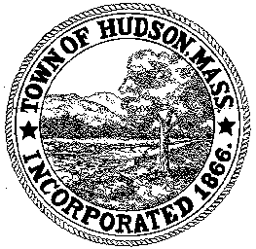

BOARD OF HEALTH
78 Main Street
Hudson, MA 01749
(978) 562-2020
Meeting Agenda
November 27, 2012
7:00 PM

- Preliminaries
1.1 Open Meeting
1.2 Roll Call

2.0 Application to Install Subsurface Sewage Disposal System
2.1 42 Wilkins Street

3.0 Application for a Stable Permit
3.1 49 Shay Road

4.0 General Business
4.1 Minutes - October 30, 2012
4.2 Voucher – BOH110812 $18,989.30
4.2 Voucher – BOH112712 $493.62

5.0 Request for Review
5.1 141/153 Broad Street
5.2 561 Main Street

6.0 New Business

7.0 Adjournment

Next Meeting: December 11, 2012

